A Guide for Dissecting the Dog
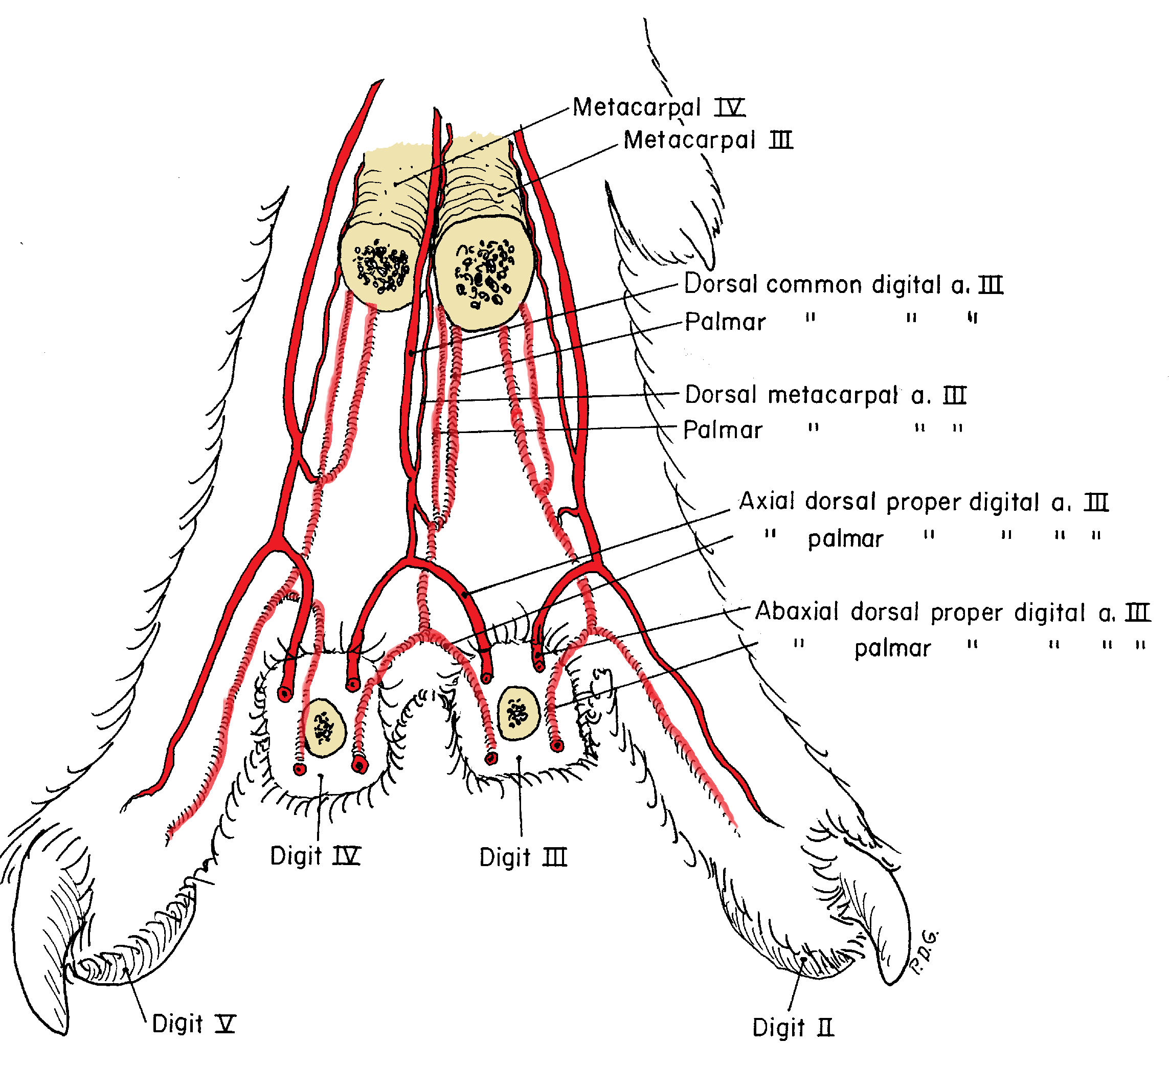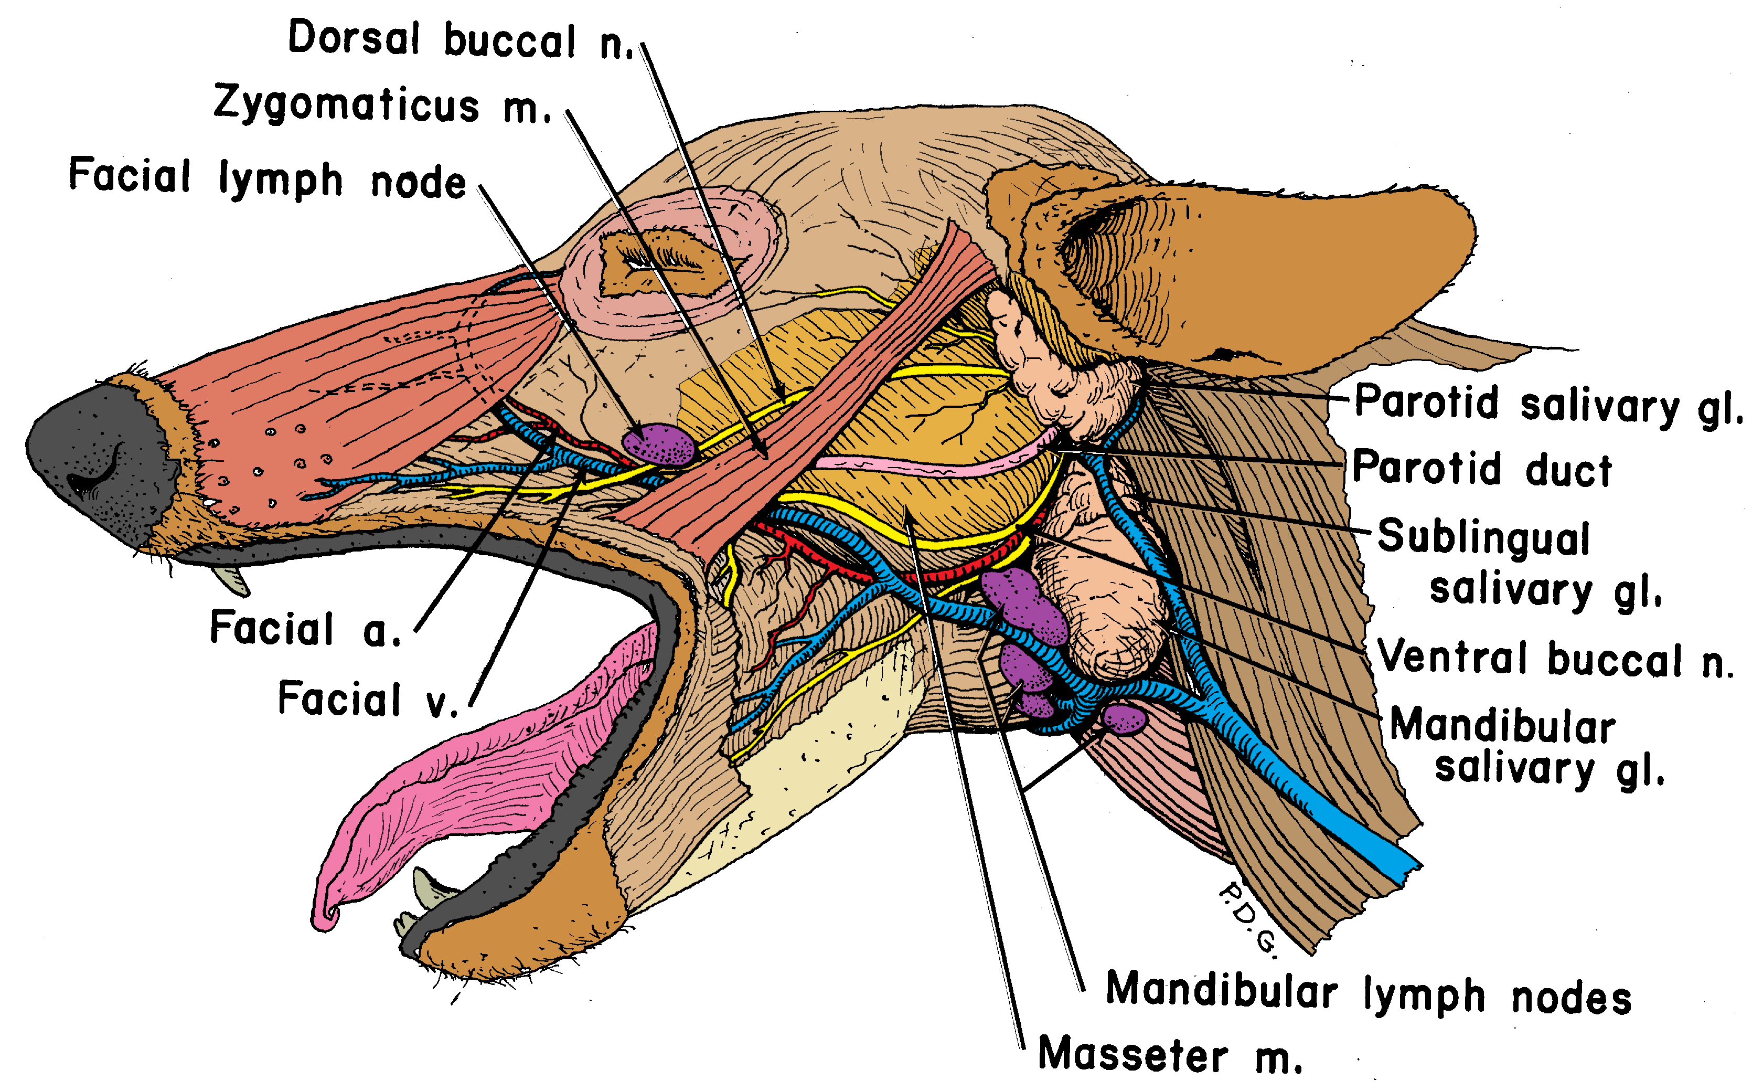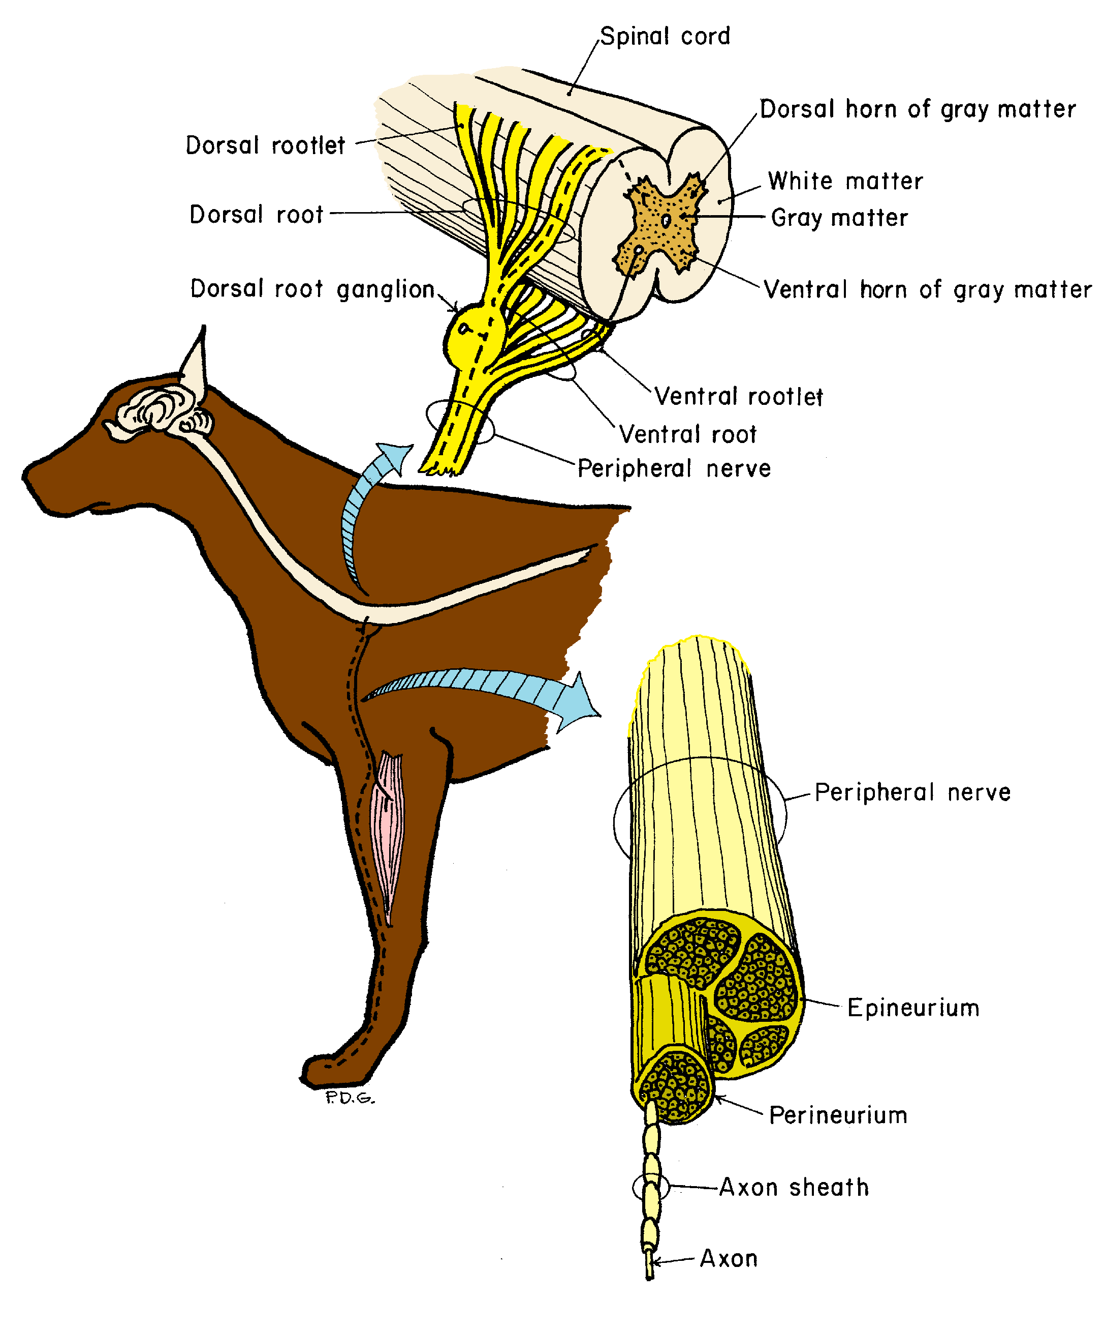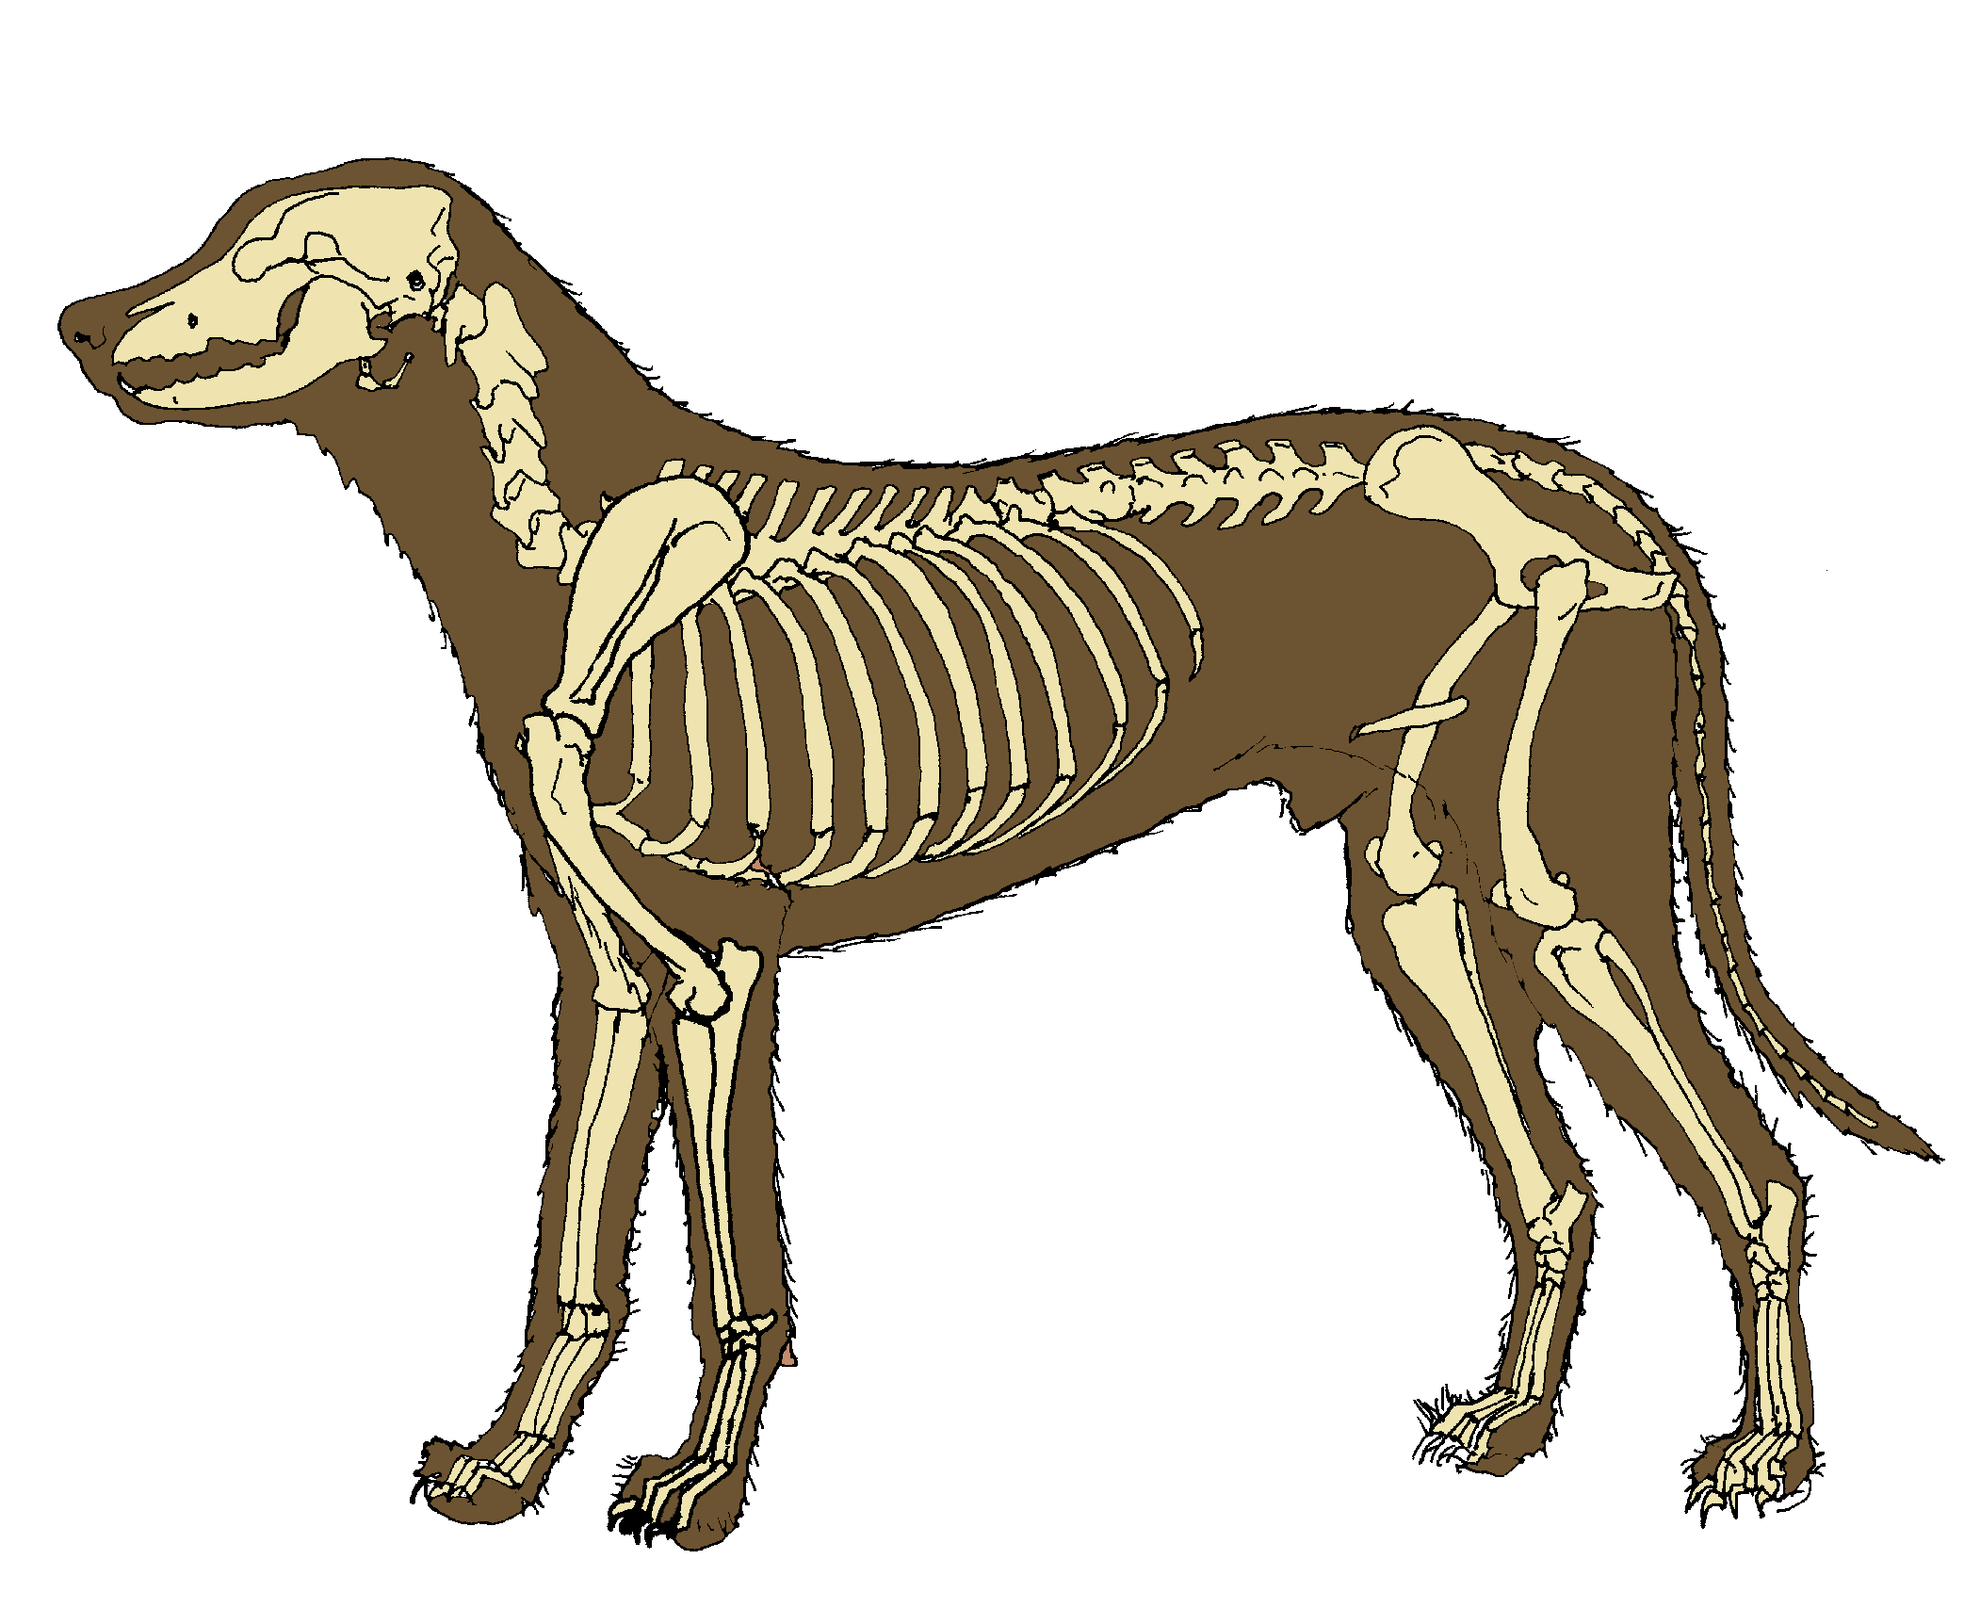
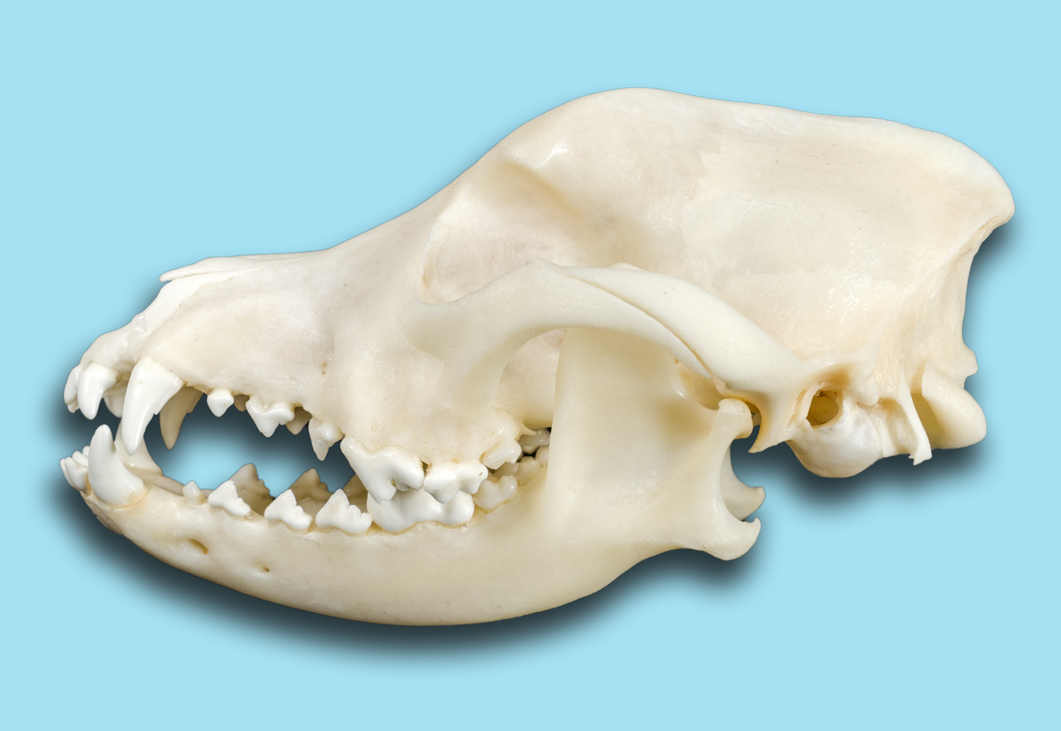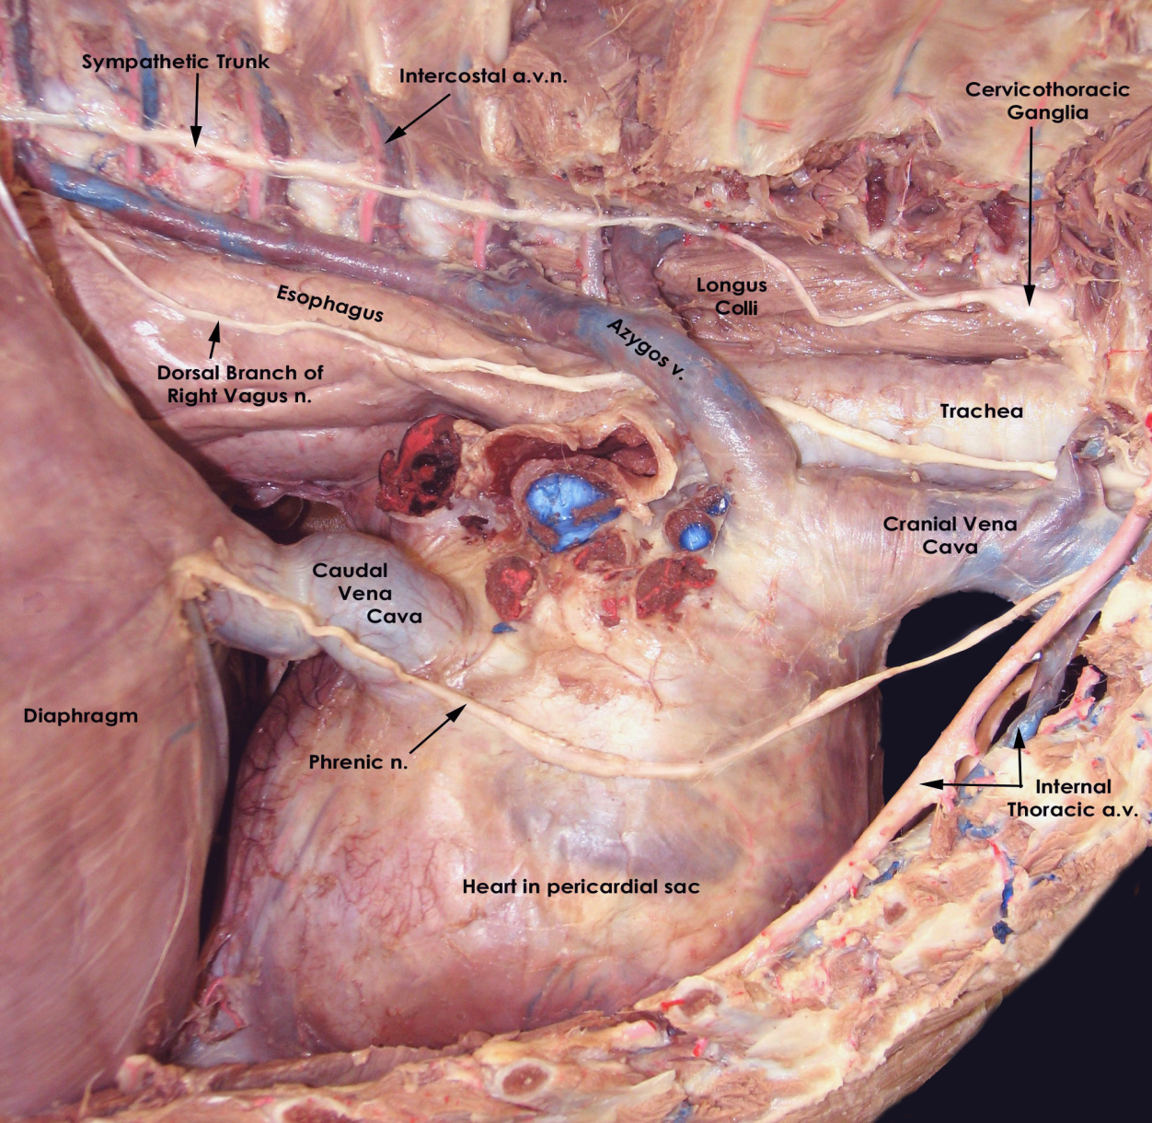

A “creative commons” licensed dissection guide:

with text by Thomas F. Fletcher, Paul F. Rumph, Phillip D. Garrett and Gerald R. Bratton; drawings by Phillip D. Garrett; and photos by Elizabeth A. Lantz, Elaine S. Coleman, D. Ray Wilhite and Paul F. Rumph.

Compiled by Paul F. Rumph, DVM, MS.
A GUIDE FOR DISSECTING THE DOG

compiled by:

Paul F. Rumph, D.V.M., M.S.
Professor Emeritus of Veterinary Anatomy
Department of Anatomy, Physiology and Pharmacology
College of Veterinary Medicine
Auburn University, Alabama

Copyright 2017

Creative Commons License=Attribution-NonCommercial: This license allows others remix, tweak, and build upon this work non-commercially, and although the new works must also acknowledge the text, photos and drawings, users do not have to license their derivative works on the same terms.

TABLE OF CONTENTS

Preface

To the Students

CHAPTER 1. Body Topography

Body planes
Directional terms
Joint movements
Skeletal system

CHAPTER 2. Thoracic Limb

Osteology
Physes
Superficial structures of the body Dissection of shoulder region
Exposure
Extrinsic muscles
Veins
Arteries
Nerves
Dissection of the thoracic limb
Shoulder
Brachium
Antebrachium
Manus

CHAPTER 3. Thorax

Axial skeleton
Body wall
Lungs and pleura
Nerves and arteries
Vasculature
Nerves, heart and pericardium

CHAPTER 4. Abdomen

Body wall
Overall topography
Peritoneum
Viscera
Vasculature

CHAPTER 5. Genitalia

Dissection for those with male dogs
First day
Second day
Third day

CHAPTER 5. Genitalia (continued)

Dissection for those with female dogs
First day
Second day
Third day
Perineum

CHAPTER 6. Pelvic Limb

Osteology
Physes
Hip
Thigh
Crus
Pes

CHAPTER 7. Back, Neck, Spinal Cord

CHAPTER 8. Head
Skull
Superficial structures
Deep dissection
Eye
Ear
Oral cavity and pharynx

PREFACE

In 1971, at Auburn University we began using an informal and unbound set of dog dissection instructions called “Fletcher’s Guide”. “Fletcher” was Dr. Thomas F. Fletcher of the University of Minnesota. In 1976, with his permission, Paul F. Rumph and Phillip D. Garrett began to modify the text to suit our time constraints and dissection sequence. The Guide was rewritten with added text, original illustrations, organization of chapters and tailoring for use with Miller’s Anatomy of the Dog by Howard Evans. Concurrently, while teaching at the University of Tennessee, Dr. Gerald Bratton added a number of clinical references to a version of the Guide. Dr. Bratton generously shared these and a few were incorporated into the Guide. This Guide was used at Auburn University for almost 30 years.

In 2017, Paul F. Rumph colorized Phil Garrett’s drawings, and incorporated the wonderful photographs of Drs. Elizabeth A. Lantz, Elaine Coleman and Ray Wilhite which they generously shared. By this evolutionary process, A Guide for Dissecting the Dog emerged. We believe its value lies in the “regional approach” method of dissection and in the excellent drawings and photographs. The extravagant and sometimes unrealistic color scheme of the drawings is intended to facilitate identification of structures.

A Guide for Dissecting the Dog has many distinctive features designed to aid students in their study of gross anatomy. In keeping with Dr. Fletcher’s original concept, descriptive material is minimal and most illustrations and photographs are designed to facilitate the dissection. Dependence on the excellent figures and descriptions in anatomy texts such as Miller’s Anatomy of the Dog by Dr. Howard Evans or Textbook of Veterinary Anatomy by Dyce, Sack and Wensing is by design. We have included several conceptual sketches that present ideas not available elsewhere in veterinary literature. When anatomical terms are introduced, they are underlined. Dissection instructions are presented in bold blue print and brief clinical comments are presented in italicized red print. Students dissect the male and female alternately so they can view and study structures on each sex before the specimens are altered or destroyed by subsequent dissection. The nomenclature throughout is that of Nomina Anatomica Veterinaria. The entire dissection sequence presented in A Guide for Dissecting the Dog can be completed in 96 hours.

Our wish is that the attributes of the Guide remain in the public realm and hope that those wishing to use the guide in total or in part will feel free to do so. The document was assembled in Microsoft Word and the drawings and photographs are jpg or other easily extracted form so they can be used in lectures or for other educational purposes. Under the Creative Commons license, permission is hereby granted to extract or rearrange material and make copies for educational purposes only. Images may not be altered. None of the contents may be sold for profit and appropriate citation of material is expected.

We wish to recognize and extend our appreciation to Drs. Fletcher, Garrett, Lantz, Coleman, Wilhite and Bratton for their contributions and cooperation in creating this work. We also wish to thank Drs. Don Buxton, Earl Cartee, and Arvle Marshall who shared our teaching duties and gave us many helpful suggestions. We thank Debbie Allgood who helped with typing and compilation of this book.
Paul F. Rumph

to the students:

Before beginning dissection, a brief word is in order about A Guide for Dissecting the Dog and how to use it.

We feel that your instruction in veterinary gross anatomy should begin with an in-depth study of general anatomy on a model animal such as the dog, and continue with coverage of the unique anatomy of other species. This guide will serve as a roadmap and includes detailed instructions for dissection of all systems with the goal of mastery of the nomenclature, relationships, and certain functional associations of anatomical structures. The extravagant and sometimes unrealistic color scheme of the drawings is intended to facilitate identification of structures.

The primary and most important objective in this course is to be able to recognize and name the component structures of the dog’s body. This ability to identify structures forms a base on which your understanding of anatomy will be built. Other objectives are to know various structural relationships, attachments, functions, blood and ingesta flow patterns and many other facts which help you build an adequate knowledge of anatomy.

As anatomical terms are introduced, they are underlined. Descriptive material is minimal and most illustrations are designed to facilitate the dissection. Dissection instructions are CAPITALIZED AND IN BOLD BLUE PRINT. Dependance on the excellent figures and descriptions in Miller’s Anatomy of the Dog by Howard Evans or Textbook of Veterinary Anatomy by Dyce, Sack and Wensing is by design. Short clinical notes are presented in red print throughout this guide. They are over and above the material for which you are responsible. However, the anatomy mentioned in these notes is also presented elsewhere and you are responsible for it.

You will be assigned to a table with several other students. This group will work together as a dissection team. Students will take turns dissecting and reading so that each will have the opportunity to develop dissecting skills and become familiar with the text.

We suggest the following process of discovery. You should prepare for each days dissection by reading the assigned pages in the guide. During the laboratory session, as you read the dissection guide, follow the dissection instructions. When an underlined term is encountered, finish the sentence or paragraph, locate a description in your anatomy text and read about the structure, consult the illustrations and then identify it on the cadaver. Many times, a helpful illustration is located nearby in the guide. Therefore, you must have your text, instruments and dissection guide in lab at all times. Always, examine each structure totally (ie. origin, termination, relationship to nearby structures, distribution etc) as far as dissection permits.

